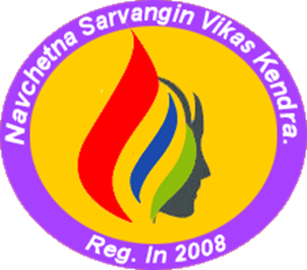

NAVCHETANA SARVANGIN VIKAS KENDRA, a non-religious, non-political, not-for-profit development organization founded in 2008 by a group of seven social women leaders who wanted to bring changes in the life of vulnerable women. Therefore, this is a women-led organization for women. The organization is registered under The Bombay Public Trust Act 1950 and The Society Act 1860. Navchetana strives to transform unjust structures of the society from grass-roots and works as a catalyst for the betterment of rural communities by providing direct and indirect support to local communities and aims to build harmonious and self- sufficient communities of diverse peoples, religions, languages, and cultures. From the year 2008, the members of the organization have been working on the socioeconomic issues for the development and improvement of the vulnerable and weaker sections of the society residing in the Beed and Osmanabad districts of Maharashtra, India. Navchetana geared up its activities since 2012 after the grave situation of COVID started subsiding
Our Core Values
Our operations are guided by the following values:
- Focus on the needy
- Be gender responsive
- Enhance utilization of local resources
- Strengthen existing structures and systems
- Encourage environmental soundness
- Promote people-centered development
- No to child labor

Operation for Year 2023 to 2024
- WOMEN EMPOWERMENT AND INCOME GENERATION
Women Empowerment process is executed in 12 Talukas of Beed and Osmanabad District covering 345 villages. In this area 2485 Self help Groups [SHGs] are active with 25600 women members. The process is multidimensional in areas of formation of collective federation trainings in governance, Govt schemes and various laws of their use. In economic empowerment 1698 groups are provided financial support to the tune of 14.20 cores and 5327 women have ventured in enterprising activities like Livestock, Agriculture, and Small shops. They are now becoming self sufficient. Women as and when needed are given professional training in business management sales, Marketing, credit linkages and account keeping
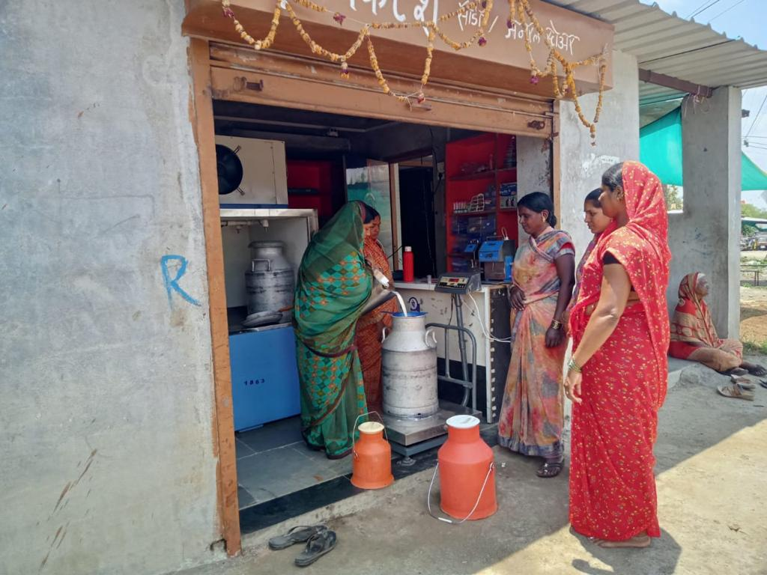 | 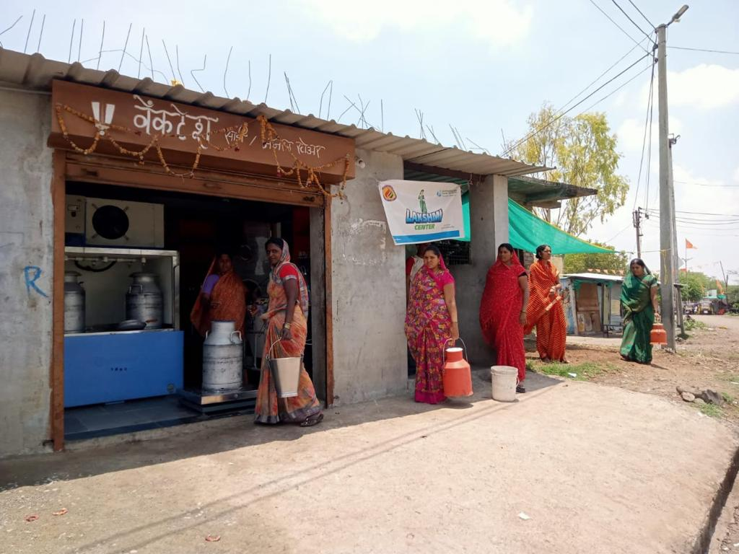
Laxmi Dairy- Milk Collection centre started and operated by women in rural village

- SINGLE WOMEN
Navchetana specially focus on the up lift ment of single women and help them to be in the process of empowerment path. It had linked 4000 deserted women from 180 villages to existing SHGs of the village. This inclusion helped 348 women to access and avail benefits under Govt schemes meant for single women. Navchetana imparted them training in Violence helped them to get various essential documents like voters, Adhar and PAN card etc. Their inclusion in group strengthen them to build their confidence and cope up with distress
- WOMEN’S SHG FEDERATION
To structure the SHGs further and to build the collective of women Navchetana formed Federation of women from 180 villages. The Federation with its collective strength is effectively working for prohibiting the violence against women and prevents their exploitation. The federation is also active in trainings in federation management health and environment also it takes rural development related issues to the administration by collective organization of women for their rights, and makes community aware about their participation in Panchayati Raj system of village.
- WOMEN GOVERNANCE
In governance Navchetana is active in larger level empowerment of women in managing local village level administration. Women are motivated to participate in village development to take active role in Gramsabha and Mahila Sabha. They are provided training in roles of various Govt servants like Gramsevak, Talathi, BDO, BEO, Monitor the school and to surface other village issues like road, water, electricity.
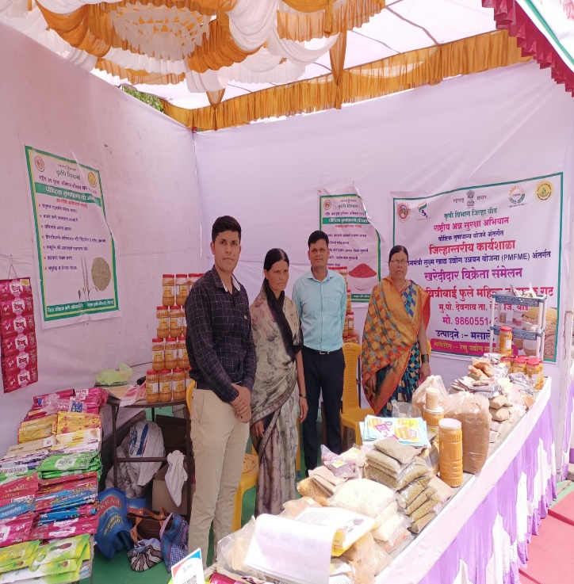 | 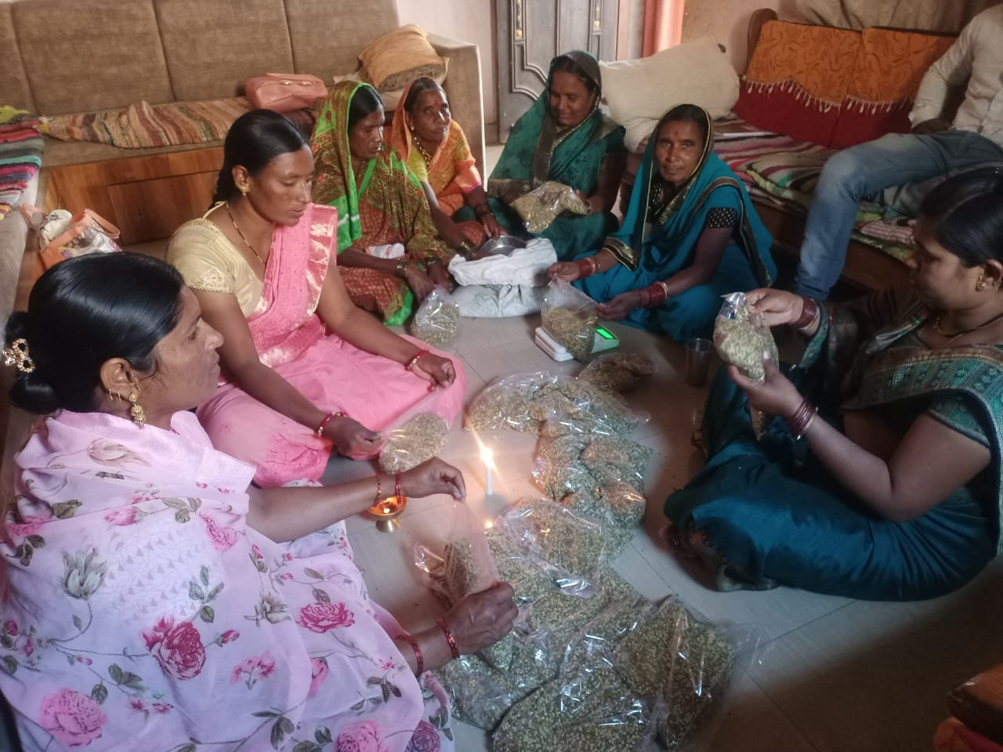

- FARMERS
Navchetana is actively engaged in Formation of farmer’s groups from 40 villages and 150 farmers groups are formed. In all 352 farmers are linked to Agro base schemes like Krushi Vidnyan Kendra, Krushi Karyalay, It organizes group discussions on natural farming as well as various issues related to farm and farm produce like insurance, crop pattern and its variance needed in crop cultivation. Presently It is active developing Model Farming on one acre of land where 100 farmers are engaged. It will be unique and sustainable Agro Based Models for sustenance of living on one acre of land

- EDUCATION
In Educational area Navchetana ventured in providing permanent school establishment namely Navchetana International English School in Dongaon fata of Umri village of Kaij taluka, The school is well build in area of 110 X 35 feet with 13 classes from Nursery to 6 class running presently. School has Principals room along with 210 children {122 boys and 88 girls} with 11 well trained teachers, with two residential care takers and one helper. The area is spread over 2 acres with excellent play ground, and separate toilets.

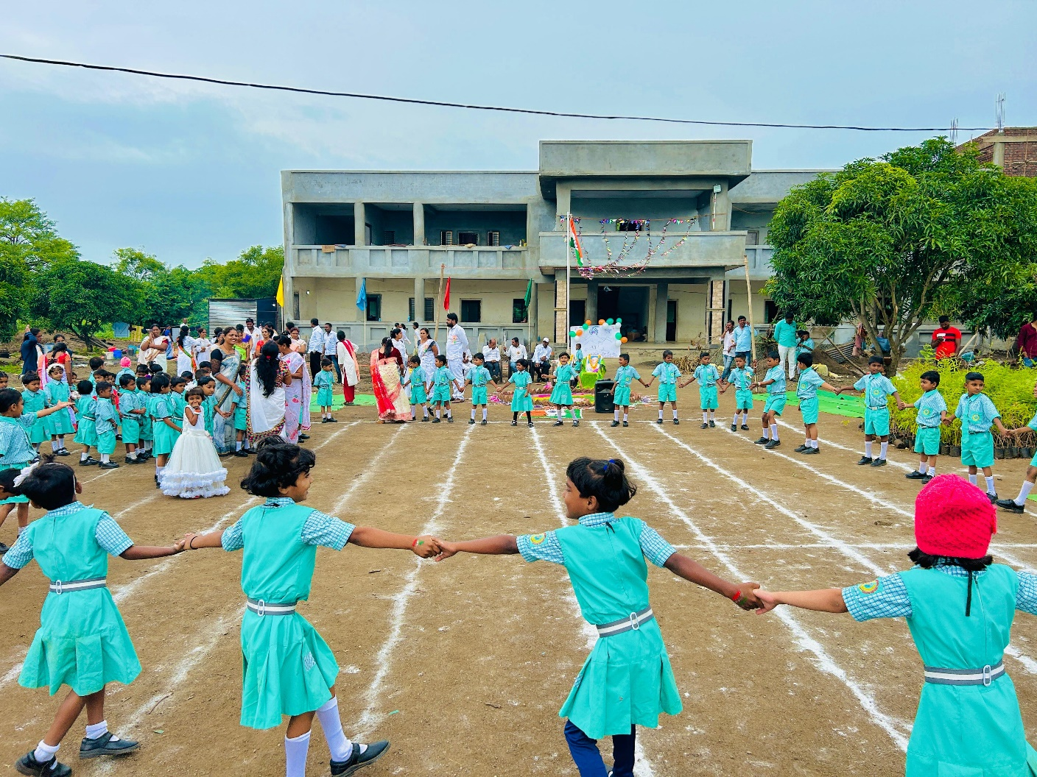

Above is the image of Navchetana International Englis Medium School

Navchetana runs Abhiruchi Classess for NT and DNT children in 5 each Pardhi and Laman habitats where efforts are made to bring 310 children in mainstream educational process of which 153 are girls and 157 boys. 112 children are already joined regular schools. Simultaneously it works with community of 40 villages where efforts are made to put children in the seasonal Hostels run by administration. With continuous follow up and advocacy The Govt has open seasonal hostels in 7 villages and 292 vulnerable children are benefited and prevented from migration along with their parents for sugar cane cutting.
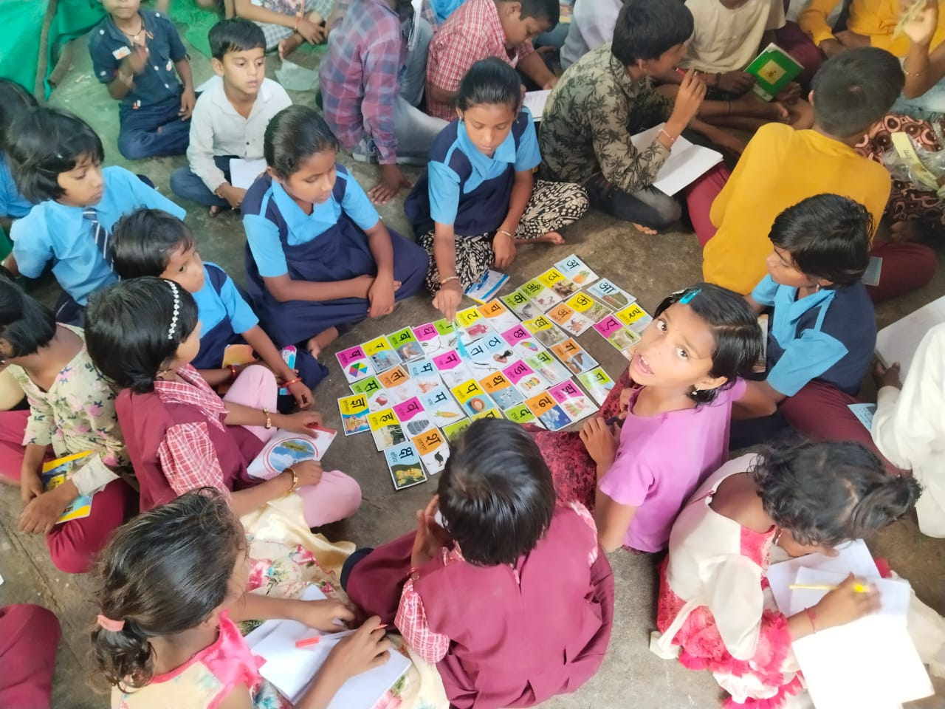 | 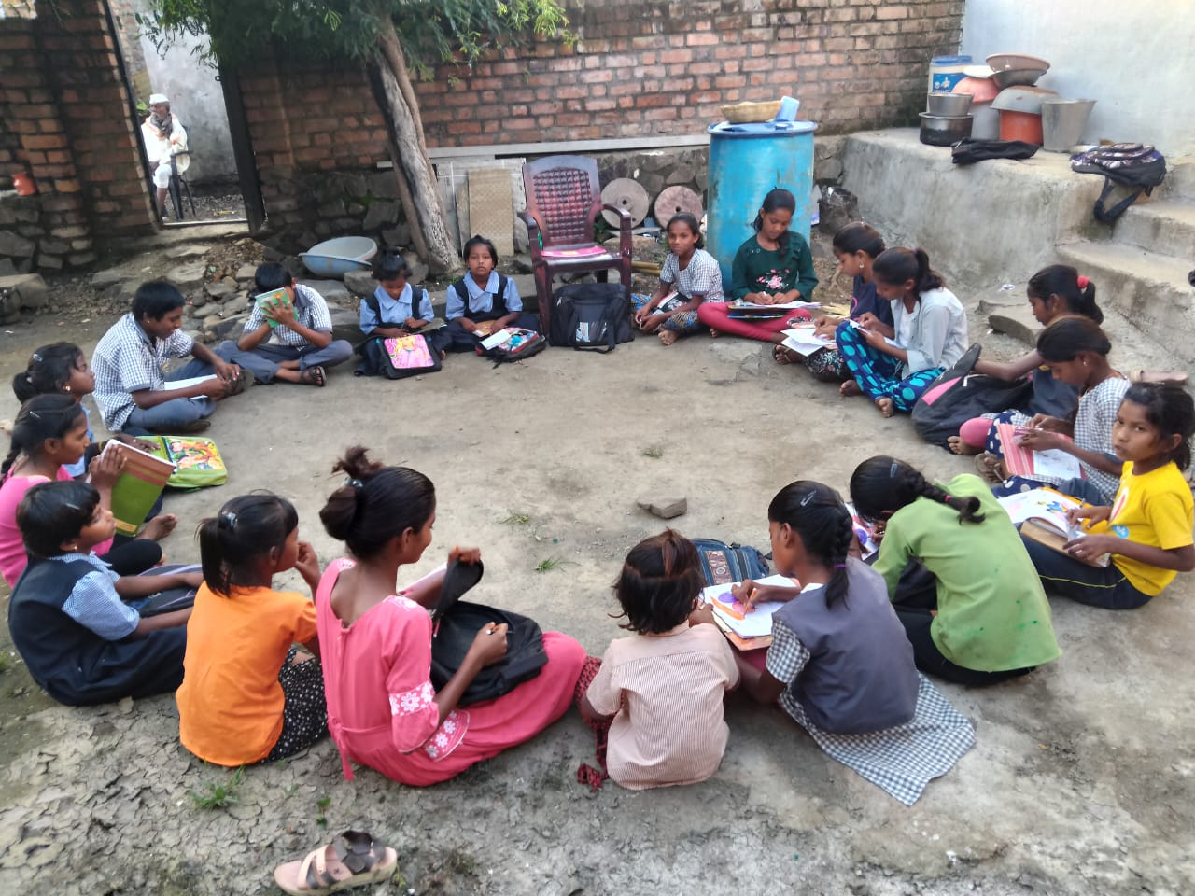
Abhiruchi class students from ND,DNT,ST Communities

ENVIRONMENT
In Climate and Environment, Principal areas are mobilizing Community participation in education and awareness of impact of climate change on life and living. In this area Navchetana initiated various related activities. It recharged 570 bore wells and 55 wells constructed 3000 soak Pits developed 516 kitchen gardens and planted one lakhs trees and constructed Bundara’s in 10 villages involving local community. Navchetana hopes to do more interventions in these areas involving farmer’s group’s school children Navchetana had mobilized women from 200 villages for plantation of one lack trees. In all 3500 community members benefitted from its environment related activities.
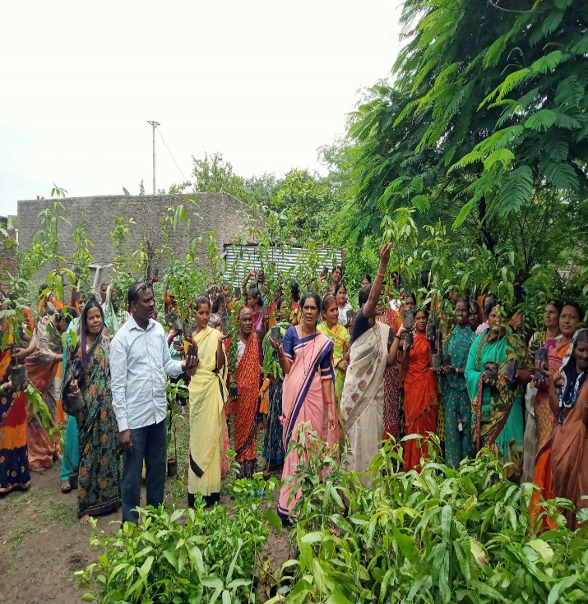 | 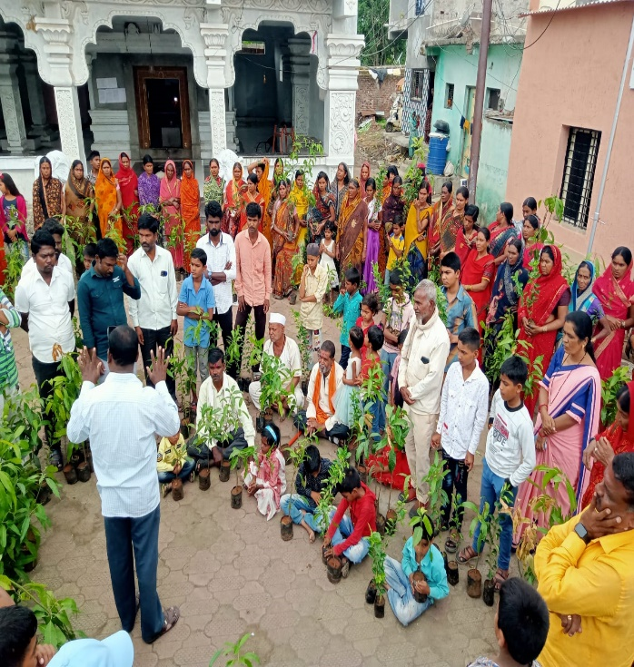
Tree plantation and awareness about environment in community

- INFORMATION AND ITS DISSEMINATION
The Govt from time-to-time issues GR, Schemes, Laws and information in the areas of social economic health related areas. This information is useful for community but it does not reach to them. Navchetana office is resource center for dissemination of the information to villagers and needy. Field level village staff through camps, meetings, workshops create awareness among community about these policies in easy language and help people to use it for their benefits
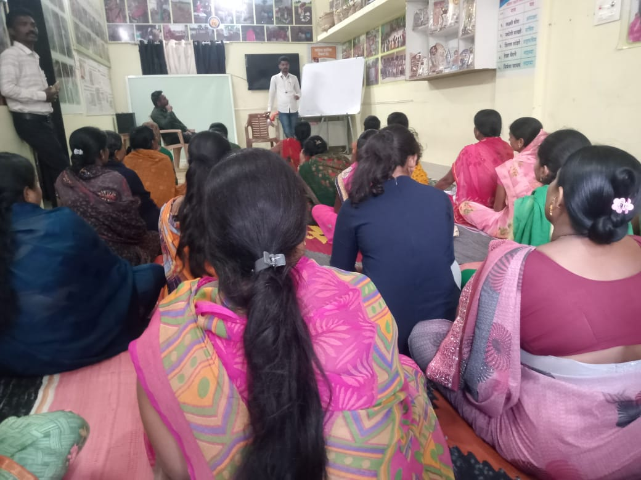
- HEALTH
Navchetana had organized health camps in the areas. This makes aware the community of its health-related issues. With the support of Health Dept, it had provided tonics to women. It regularly accompanies the health staff in Vaccination campaign and follows up with villagers.

Thank You,
Navchetana

