Annual Report 2022-2023

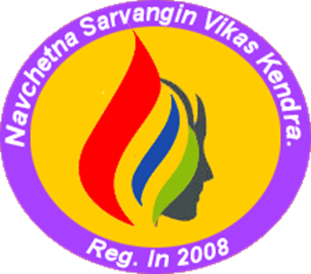

Navchetana Sarvangin Vikas Kendra

Address | At.Po. Shikshak Colony, near Jeevan Shikshan Vidyalay, Kaij-Beed Road, Kaij District: Beed -Pin Code: 431123 (Maharashtra) India
Contact Number | +919075472959
E-mail ID | navchetana2008@gmail.com
Website | navchetna.org

Navchetna Sarvangin Vikas Kendra (Navchetna) is a grassroots organisation working since 2008 to bring new innovations in development to root out poverty from the areas by working on livelihood of poor families. Navchetana strives for transforming unjust structures of the society from grass-root and works as a catalyst for the betterment of rural communities by providing direct support to local communities. Navchetana largely works with grassroots women who have been putting their efforts in the social development field for the rights of the women. These members had a strong grassroot foundation and had experience working with women from rural background.
Navchetana is working in Beed, Osmanabad, Latur and Ahmednagar Districts in Marathwada Region of Maharashtra. It has impacted the lives of more than 50,000 people from marginalized sections of society. Over 80% of the households impacted by Navchetana's work belong to marginalized communities like Dalits, NT/DNTs and underprivileged women. Over 90% of beneficiaries are women who form a core group for program interventions.
- VISION
Organisation’s vision is to create equitable society which ensures equal rights and opportunities to women and the deprived, enabling them to live a life of dignity and freedom.

- MISSION
Capacity Building and strengthening of destitute and deserted single women, Dalits, backward women, and children to constantly facilitate justice in social, educational, and economic development with self-initiative and integrated manner.

Major Activities in year 2022-2023
- Rural women and livelihood creation in Beed district to stop migration
As the district is known for sugarcane cutter labour supplier’s district and due to no industrialisation in the district employment is a major issue in the field. Most of the families are migrant workers and do migrate each year for sugarcane cutting in nearby districts as well other states like, Karnataka. Going through the scenario organization thought to start a small milk dairy centre in the selected three villages in Beed district in which women are the major who are migrating in the search of jobs as sugarcane cutting workers and face so many issues related to health, hygiene, and personal issues of women along with heavy work load in the sugarcane cutting.
Navchetana along with community members came together and in group decided to start a small milk collection unit at their own village, as most of the community owns a land in 5-7 acres but able to cultivate only 2-5 acres of land and so all the remaining land is remained unused for a long time. So, plenty of green grass is available to animals free of cost and grazing land can be used for animals based on discussion with community Navchetana requested financial institution to provide financial support to SHGs to start their own dairy farming and repayment responsibility was taken by Navchetana.
Community got financial support and started dairy farming in rural areas of Beed district in 3 villages. Now this dairy farming at villages owns by migrant workers for sugarcane cutting who were used to go for 4-6 months out of their village along with children and animals and had to suffer a lot mentally, physically, and emotionally too. Also, children had to suffer by moving out of education and get ill health due to insufficient nutritional food. Now community members are engaged at their own village along with family members and getting daily earning of Rs. 300-500 per day by milk collection, also they can feed animals a fodder and green grass along with advice of veterinary Doctor who are appointed by Navchetana gives advised to community on health issue of animals provide free of cost treatment to animals.

Below are some images of women’s dairy farming and milk collection centre.

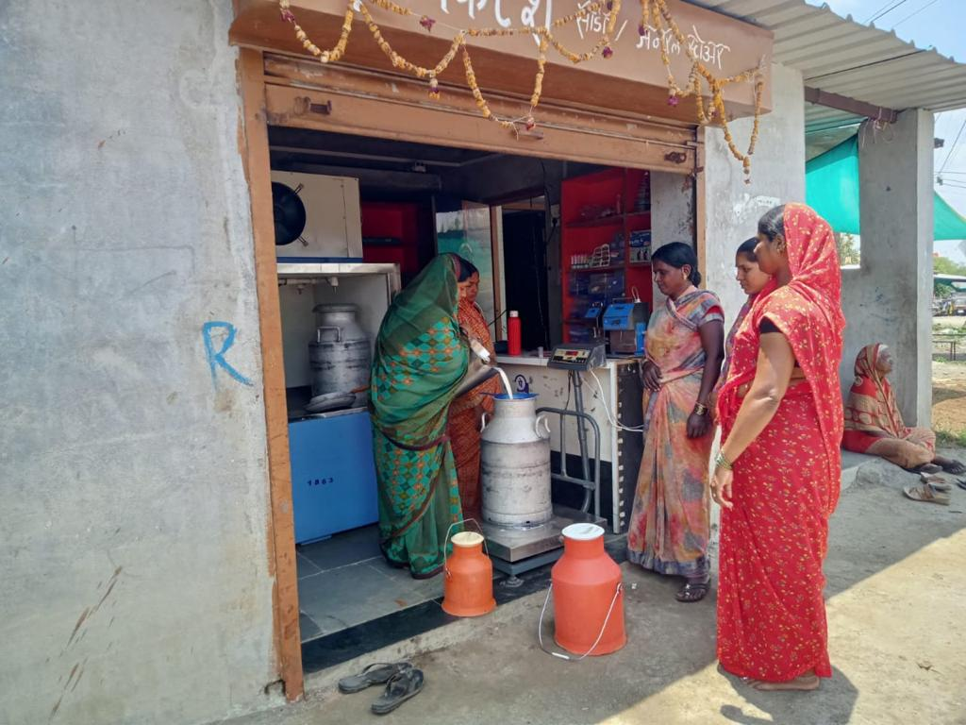

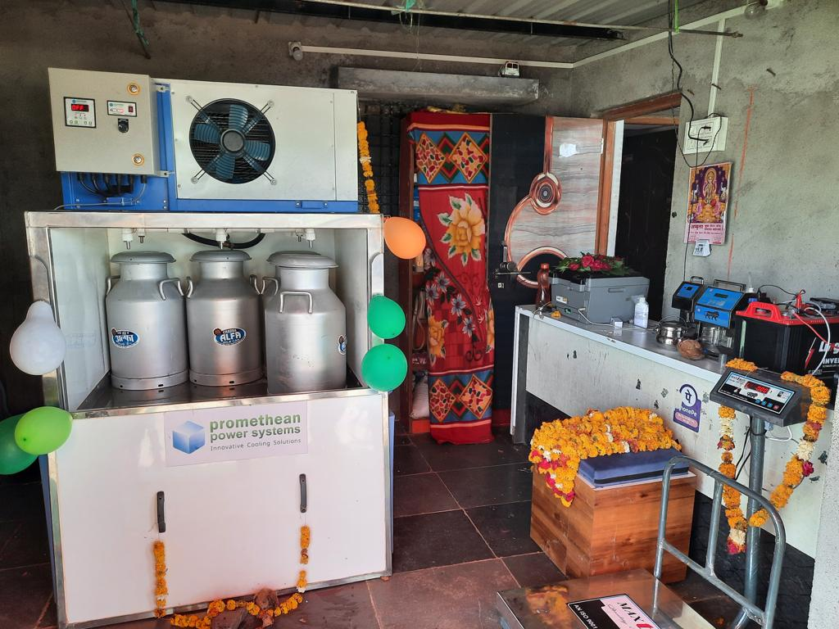

- Work with NT/DNT Communities: - Abhiruchi Varg
Abhiruchi Varg is concept to bridge the gap between regular government school and the Tribal community with whom we are working known by various names i.e. Wadr, Pal Pardhi, Kaikadi, Gopal, Gosai, Joshi,Pardhi, Face Paradhi, laman, Gond, Bhilla and many others and from generation after generation, these tribes have had wandering traditions and they have hardly been integrated in the society. Large numbers of children of these communities never entered schools even after the implementation of Sarva Siksha Abhiyan (SSA), RTE Act, and loud claims made by government, as such. These children are engaged in taking care of their siblings, in domestic work, in earning money for food to support their parents or begging on the streets. Navchetana is working in 30 hamlets of NT, DNT communities on providing them basic documents i.e. ration card, Aadhar Card, Caste certificate, birth certificate, water, electricity, school, and other government schemes through advocacy with the district administration.
Keeping in mind the struggle of these tribes we got support from HCF foundation and started working in selected 10 Padas,/Wasti and started Abhiruchi Varg in which we trying to bridge the gap between school teaching and children for that we have set up 10 Abhiruchi Vargas in each selected villages where we have appointed teachers who can teach in languages of NT/DNT communities so that children can understand and grasp easily. The time of the school is as per the suitability of children and parents and teaching pattern is with playing and using local language. In this school we are teaching the subject which are in their class at Government school and children who are not going to Government school easily able to complete the syllabus and after that can write exam. We linked them in Government school after classroom teaching and children do continue their education.
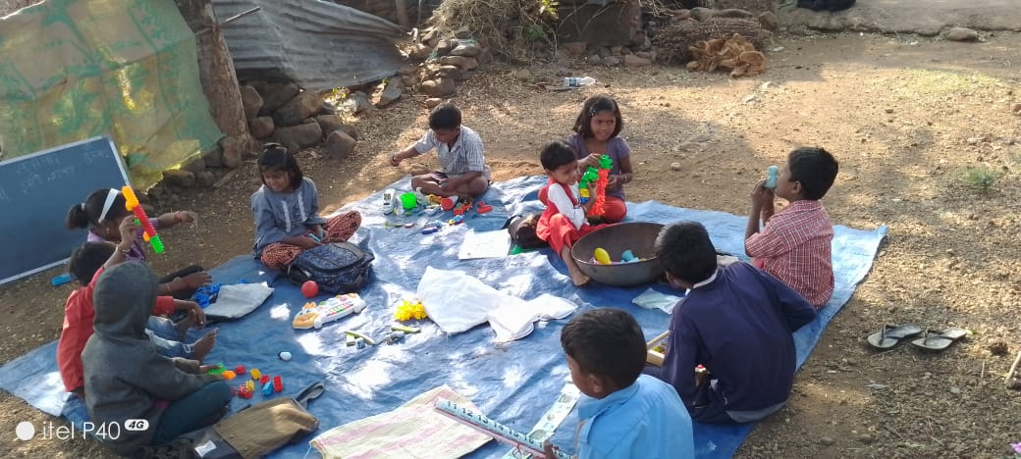
Image of Abhurichi Varg

- Awareness Among community regarding child marriage
Navchetana is also working with Kailash Satyarthi Children’s Foundation (KSCF) a partner for awareness generation among community about child marriage and its negative impact, child rights and capacity building of community about to stop child marriage. As partner in the field team of Navchetana made awareness among community about child rights and took pledge from PRI members and community to stand against child marriage and not to allow any kind of child rights violation may be its child marriage.
During the work among community, we were able to stop 4 child marriages, made counselling of the both families involved in and took help of police and village level administration for this act. We are constantly in touch with community and district administration for their cooperation and support as and when required to stop child marriage and its negative impact over child, and working so there should not be any kind of child rights violation.
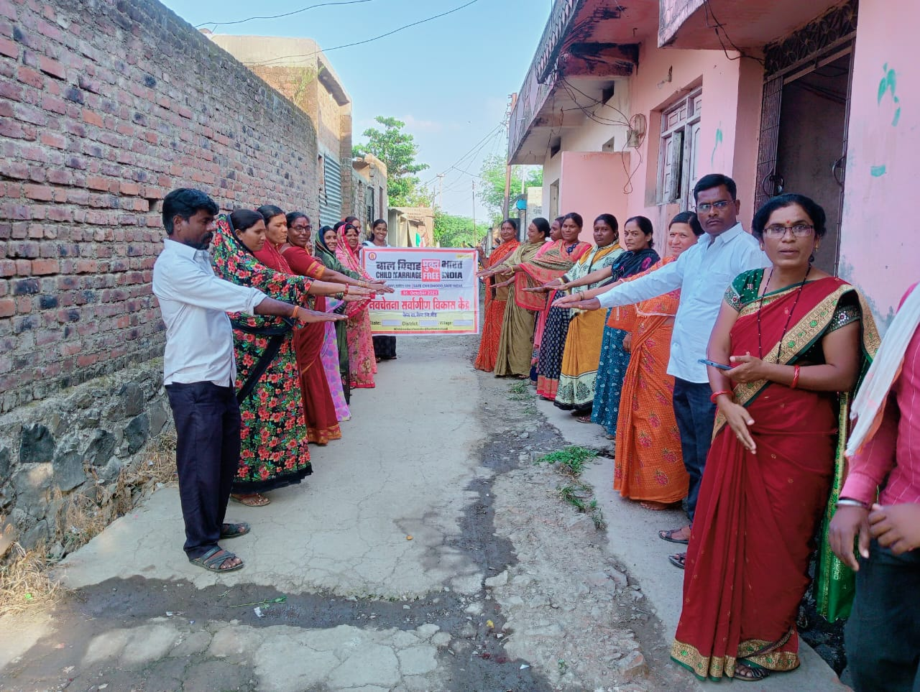

Other Regular Activities of the Organization

- Women SHGs and Village Development
With purpose of empowerment of women organization has formed 3227 women SHGs in 178 villages. Out of that 2011 women SHGs have been linked with finance institutes and implementing savings. So for Rs. 17 crores have been distributed as credit to 16041 women for health, education and livelihoods purpose. 12 women SHGs were given training on marketing and managing micro enterprises. Women have been coming forward to solve issues of drinking water, drainage, road, electricity at village level. The successful organization of women and their success in solving many issues in the villages had been a cause for celebration and source of courage and conviction for women to work for their own development.
In every village, on average 3-4 women are taking the lead role in organizing women to fight for their right and to set right many unsolved issues of the village. Effective discouragement on domestic violence, safe and clean drinking water, delivery of women should be done in hospitals/health centers, free health facilities, Clean village etc are the issues for which the women are now fighting. Women are also making efforts to get mid-day meal for the children in the anganwadis.

- Women’s role in Panchayati Raj Institutions (PRI)

All the women panchayat members of the target villages are closely linked to the SHG’s the more active amongst them are the ones who have been elected through reservation. The SHGS and PRI members are also educated about their roles and responsibilities and all the SHG women are urged to constantly support and prod the panchayat members to look into the issues in the village. In all the villages, the SHG women expressed their desire for exclusive women’s gramsabaha’s in their villages.

- Federation of women SHGs
Navchetana has facilitated formation of women’s federation and now 34,000 women are members of this federation. the core function across federations is to organise women for promoting and strengthening livelihoods,
- ensuring women’s rights, and
- Securing justice.
One main objective of promoting SHG federations is to overcome the inherent limitations of small and informal groups–the SHGs–such as limited resources, capacity, and negotiation and bargaining powers, and an inability to deal with the outside world– the government, mainstream institutions, markets, etc.
- Navchetna Mahila Udhyog
in order to reduce the seasonal migration. It is necessary to develop a new ecosystem of livelihood resources, link these people with various financial and business institutions, inspire them to venture in and start new work, help them develop and/or upgrade their livelihood resources. With all these objectives, Navchetana has started an initiative called Navchetana Mahila Udyog. This entity includes one unit of petticoat manufacturing. About 380 women have got a regular employment opportunity in this unit and there are another 2700 women who got work during summer season with summer dried snacks which are consumed by the people throughout the year has trained 1000 poor women on tailoring and provided sewing machine to 500 women. These women are earning 200-250 rupees per day.
- Migration, Education and hardship
There are no industries except sugar factories which also are in debt and unable to repay the farmers dues. Under this situation most of the underprivileged communities including nomadic tribes, scheduled castes (Dalits) are forced to migrate to other parts of the state as well as neighbouring states in search of livelihoods organisations working with communities that migrate every year for the sugarcane cutting prevailed upon the state government to initiate steps to ensure continued education for the children of these agricultural labourers. The result was a Government Resolution, first in 2010 and modified 2014, to provide for seasonal residential hostels for such students.
Navchetna has supported 2,000 families and manage to stop their migration. Their children could continue their education. SO usually the parents prefer to migrate along with their children. As a result, many children remain absent from the schools for more than 6-7 months and eventually gets dropped out. This affects severely on education and overall development of these children.
In order to help such parents, understand importance of education, a massive awareness drive was organised to enrol such type of children in temporary hostels started by the state government. In order ensure that these hostels are run as per the government norms, Navchetana did regular follow-up with the education department. This resulted into stopping of migration of 317 children this year. In addition to this, a special drive was undertaken targeting NT/NTD tribal (Paradhi) habitations to create fondness among children and parents towards the education. In such habitations, education is imparted in a more interactive, playful environment. This helped to bring back more than 200 children to schools in their respective villages.

