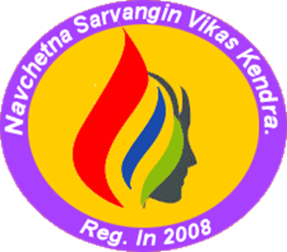

Address | At.Po. Shikshak Colony, near Jeevan Shikshan Vidyalay, Kaij-Beed Road, Kaij District: Beed Pin Code: 431123 (Maharashtra) India
Contact Number | +919075472959,+919921326262
E-mail ID | contact@navchetna.org
Website | navchetna.org

From The Secretary’s Desk
“Navchetna as an organization became 14 years old and have been able to create a system of development that promotes sustainable development and empowering voiceless and most marginalized groups. The journey so far has been an exciting one, with many feathers in our cap. But there are many more milestones awaiting us. The landscape of social development sector is interestingly changing. In another 10 years, the United Nations plans to achieve the 17 Sustainable Development Goals. As the clock ticks away, we must address challenges in front of us which are as poverty, inequality, climate change, environmental degradation, inequality, peace, and justice. The scope of work at this juncture is immense, and I am happy that Navchetna is playing an active role in the development sector.”
I am thankful to our donor partners, who have been an essential part of our efforts. Thank you for standing by us every step of the way and I hope that we can count on your continued support in the years to come.
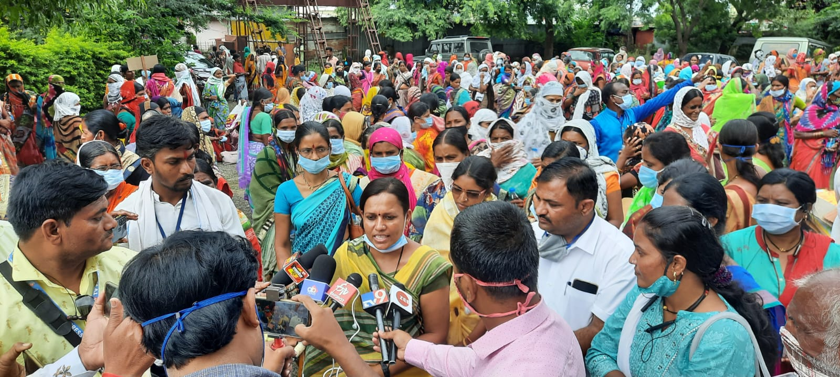

Ms. Manisha Ghule

Secretary
About Navchetana Organization
Navchetna Sarvangin Vikas Kendra (Navchetna) is a grassroots organisation was formed in 2008 under Bombay Public Trust Act & Society Registration Act to bring new innovations in development to root out poverty from the area. Organization works to make significant changes in livelihood of poor families. Navchetana strives for transforming unjust structures of the society from grass-root and works as a catalyst for the betterment of rural communities by providing direct support to local communities. Navchetana largely works with grassroots women who have been putting their efforts in the social development field for the rights of the women. These members had a strong grassroot foundation and had experience working with women from rural background.
The organization has been working on the issues of health, education, and livelihoods largely in the Kaij, Dharur and Ambejogai talukas of Beed district and is active in 300 villages of Beed District in Marathwada Region of Maharashtra. It has impacted the lives of more than 50,000 people from marginalized sections of society. Over 80% of the households impacted by Navchetana's work belong to marginalized communities like Dalits, NT/DNTs and underprivileged women. Over 90% of beneficiaries are women who form a core group for program interventions. The backbone of Navchetana’s work is the empowerment of rural communities, particularly in underprivileged communities and for women - through collectivization as well as the promotion of individual enterprises. Building self-reliant people's institutions for financial inclusion, livelihoods enhancement and improved rural governance is the heart of the organization's approach.

- Vision

Organisation’s vision is to create equitable society which ensures equal rights and opportunities to women and the deprived, enabling them to live a life of dignity and freedom.

- MISSION

Capacity Building and strengthening of destitute and deserted single women, Dalits, backward women, and children to constantly facilitate justice in social, educational, and economic development with self-initiative and integrated manner.

Major Activities in year 2021-2022

- Women SHGs and Village Development
With purpose of empowerment of women organization has formed 3227 women SHGs in 178 villages. Out of that 2011 women SHGs have been linked with finance institutes and implementing savings. So for Rs. 17 crores have been distributed as credit to 16041 women for health, education and livelihoods purpose. 12 women SHGs were given training on marketing and managing micro enterprises. Women have been coming forward to solve issues of drinking water, drainage, road, electricity at village level. The successful organization of women and their success in solving many issues in the villages had been a cause for celebration and source of courage and conviction for women to work for their own development.
In every village, on average 3-4 women are taking the lead role in organizing women to fight for their right and to set right many unsolved issues of the village. Effective discouragement on domestic violence, safe and clean drinking water, delivery of women should be done in hospitals/health centers, free health facilities, clean village etc are the issues for which the women are now fighting. Women are also making efforts to get mid-day meal for the children in the anganwadis.

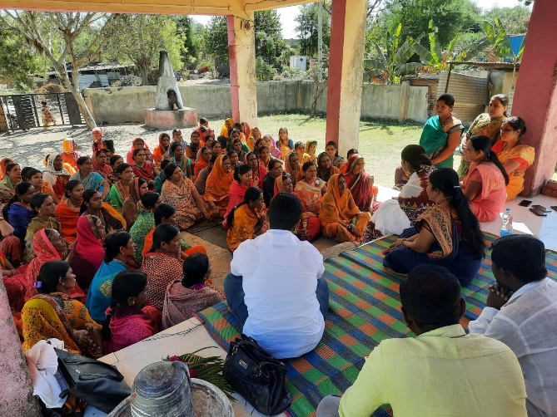
- Women’s role in Panchayati Raj Institutions (PRI)
All the women panchayat members of the target villages are closely linked to the SHG’s the more active amongst them are the ones who have been elected through reservation. During the meetings with the women panchayat members and other SHG women, it had been emphasized that, the members should always look out to discharge their duties fairly and for the satisfaction of one and all of the community. The members are also educated about their roles and responsibilities and all the SHG women are urged to constantly support and proud the panchayat members to look into the issues in the village.
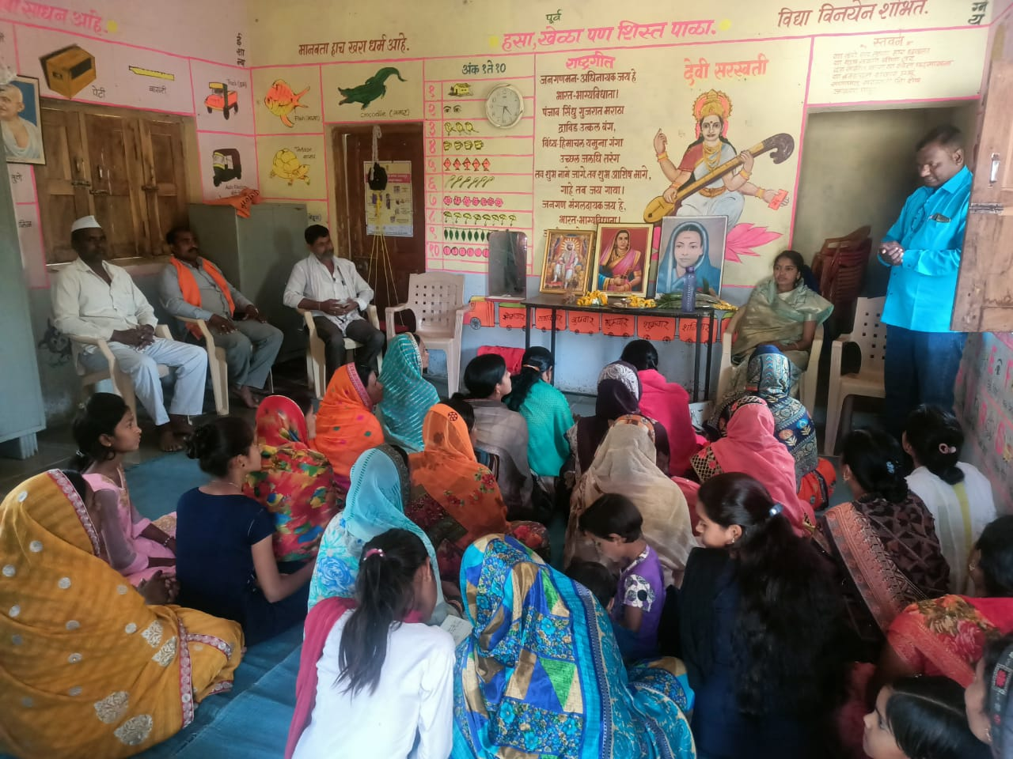

In all the villages, the SHG women expressed their desire for exclusive women’s gramsabaha’s in their villages. women’s participation in PRI is increasing and development of panchyat is becoming possible as per the vision of women. We plan to ensure women’s participation and support in enhancing the village’s natural resources. During the gramsabha which was held in the first half of the project year, women raised many important issues. Being not satisfied about the inactiveness of the administration on the issues raised by them the women consistently pursued the matter with the authorities. This has resulted in some positive outcomes also.
- Federation of women SHGs
Navchetna has facilitated formation of women’s federation and 34,000 women are members of this federation. The agenda is constantly evolving, but the core function across federations is to organise women. This branches out in three broad directions which are as,
- promoting and strengthening livelihoods,
- ensuring women’s rights, and
- Securing justice.
One main objective of promoting SHG federations is to overcome the inherent limitations of small and informal groups–the SHGs–such as limited resources, capacity, and negotiation and bargaining powers, and an inability to deal with the outside world– the government, mainstream institutions, markets, etc. The benefits of federations include those arising from (a) economies of scale, (b) reduction in transaction costs, (c) reduction in default rates at all levels, (d) value added services, (e) reduction in the cost of promoting new SHGs (that is, the cost of reaching out to every poor woman) and (f) increasing levels of financial discipline and accountability among SHGs,promoting leadership skills and governance among SHG members; and developing poor people’s own institutions. The concept of a federation emerged from the felt need of the women SHGs that were functioning well and keen to come together for sharing experience and learning. The rationale behind the promotion of federations is: i) to strengthen existing SHGs, ii) to promote new SHGs of the poor, iii) to access various services to member SHGs, iv) to provide a sense of solidarity among members of different SHGs in an area, v) to enhance sustainability of the SHG movement, vi) to facilitate linkages and vii) to empower women. Besides, federations play an important part in SHG capacity building and conflict resolution—both internally and externally. SHG federations sometimes assist promoting institutions and at other times are of direct benefit to members.
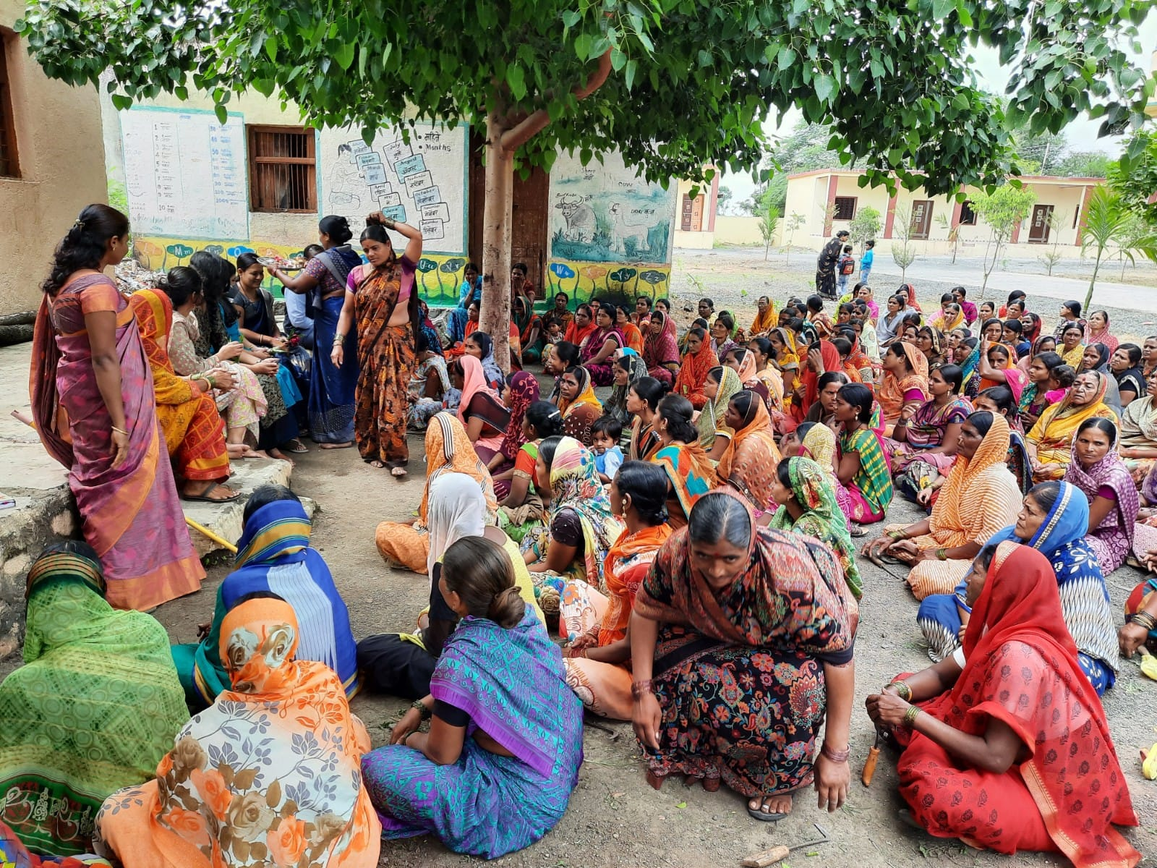

- Navchetna Mahila Udhyog
Navchetana has been working in Beed district which is also known as a “District of Sugarcane Cutting communities”. We work on various aspects in order to reduce the seasonal migration. It is necessary to develop a new ecosystem of livelihood resources, link these people with various financial and business institutions, inspire them to venture in and start new work, help them develop and/or upgrade their livelihood resources. With all these objectives, Navchetana has started an initiative called Navchetana Mahila Udyog. This entity includes one unit of petticoat manufacturing. About 380 women have got a regular employment opportunity in this unit and there are another 2700 women who got work during summer season with summer dried snacks which are consumed by the people throughout the year
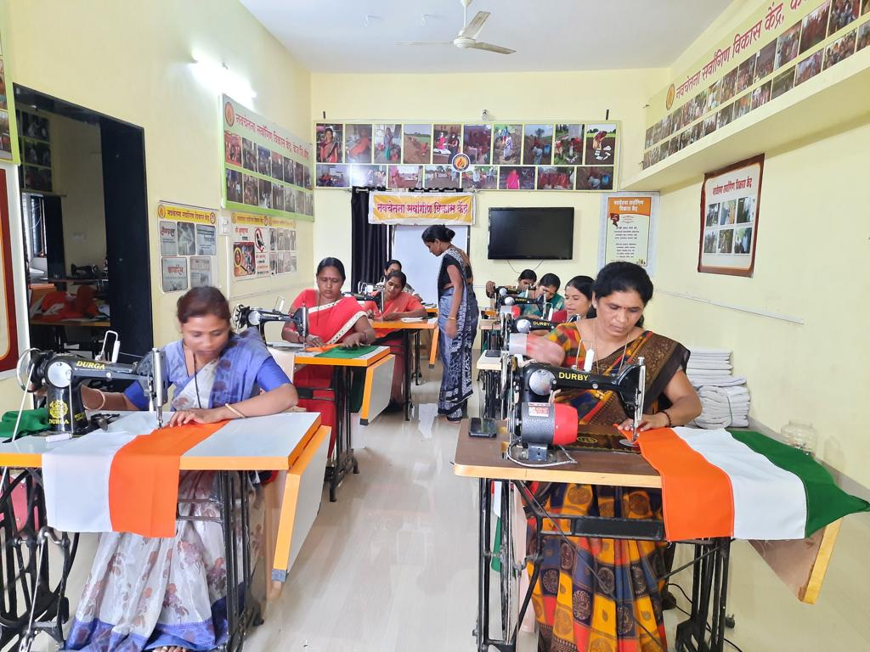

Navchetna Mahila Udhyog has trained 1000 poor women on tailoring and provided sewing machine to 500 women. These women are earning 200-250 rupees per day. Through that support and skill, they are living dignified life and no more facing domestic violence. Mahila Udhyog conducted market survey on petticoat, blouse and legis in taluka places, Beed, Osmandbad and Latur cities. The traders in these cities showed interest to buy petticoats, blouse and ligis made by the women in Navchetna Mahila Udhyog Kendra, there is approximately demand of 100,000 petticoat every month in those cities.

- Migration, Education, and hardship

There are no industries except sugar factories which also are in debt and unable to repay the farmers dues. Under this situation most of the underprivileged communities including nomadic tribes, scheduled castes (Dalits) are forced to migrate to other parts of the state as well as neighbouring states in search of livelihoods. The situation is grim for the women, which is further marginalized group amongst already marginalized communities with no additional support in their villages of Beed district have little recourse but to take their children along when they migrate for work. The vulnerability of children is aggravated because they do not have access to the kinds of support which non-migrant children automatically have.

Children and their education have traditionally been affected in Beed district that see large scale seasonal migration, particularly for the sugarcane cutting season. Navchetana has supported 2,000 families and manage to stop their migration. Their children could continue their education. So usually, the parents prefer to migrate along with their children. As a result, many children remain absent from the schools for more than 6-7 months and eventually gets dropped out. This affects severely on education and overall development of these children.
In order to help such parents, understand importance of education, a massive awareness drive was organised to enrol such type of children in temporary hostels started by the state government. In order ensure that these hostels are run as per the government norms, Navchetana did regular follow-up with education department. This resulted into stopping of migration of 317 children this year. In addition to this, a special drive was undertaken targeting NT/NTD tribal (Paradhi) habitations to create fondness among children and parents towards the education. In such habitations, education is imparted in a more interactive, playful environment. This helped to bring back more than 200 children to schools in their respective villages.
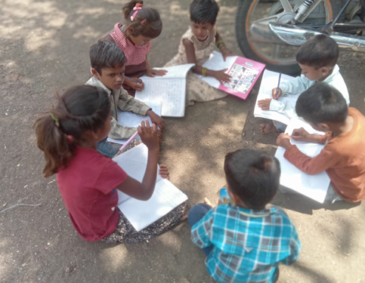

- Health, Cleanliness and Awareness
Health is also a one of the major issues faced by the women. To address this issue, Navchetana organizes health camps. Such camps are helping women, children, adolescent girls to be aware about health and nourishment related issues as well as they get free medicines kids and malnourished women with support from health department. Navchetana also helps women get benefits of various health schemes such as Janani Suraksha Yojana.

To address health issues of target community, help them to get the basic health services in Primary Health Centres and rural hospitals and make them aware about health issues, Navchetana Team has been doing regular follow up work with Health Department and related agencies. Navchetana is also working with local administration to execute Village Cleanliness drive in several villages. Women’s network is leading this front. Navchetana supported women for backyard vegetable gardening and keeping home clean. In this regard distributed IEC material like posters, pamphlets etc. Navchetana organizes health awareness drives through rallies and camps.

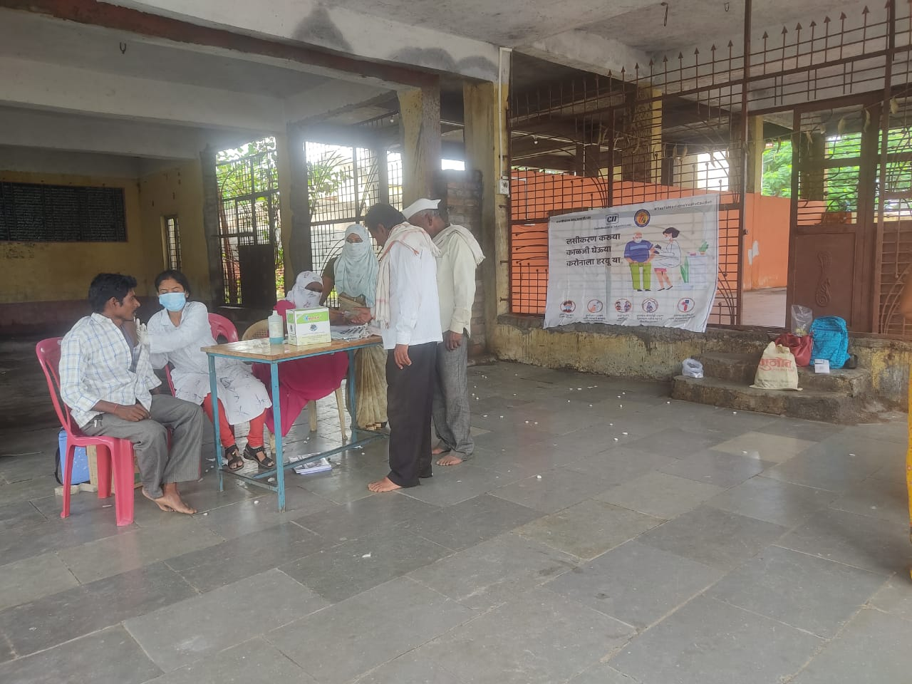 | 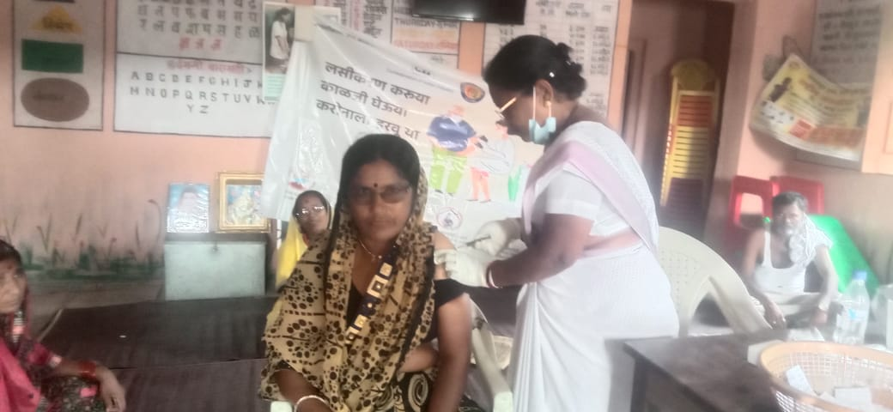

- Work with NTDNT Communities
From generation after generation, these tribes have had wandering traditions and they have hardly been integrated in the society. In fact, the society has always looked at them with mistrust and suspicion due to the stigma of criminality attached with them. In that sense they have been living a life of isolation from the rest of the society. Some of these tribes still prefer to stay near jungle, away from the villages. Their temporary settlements are known as pal or pada.

As already mentioned these tribes have wandering traditions. In absence of any means of survival and lack of education to fit into the settled society they are forced to continue with this tradition for bare survival in the most degrading and sub human conditions. Thousands of families belonging to these tribes wander from place to place and stay in temporary structures rarely fit for humans beings to stay. Unless they settle at one place or another, unless they are provided with opportunities of education and employment they will never be in a position to integrate themselves in the society and avail of the benefits of modern civil life.

Though Criminal Tribes Act was repealed in 1952 the stigma of criminality is still attached with them. Due to this stigma they are the victims of persecution and torture at the hands of the British and the state machinery. Anywhere an act of theft or robbery takes place persons belonging to these tribes in the surrounding area are arrested and subjected to various forms of torture. States and a section of civil society organisations often view these communities through the framework of social morality. These communities continue to be marginalised.In the eyes of the society they are still criminals, and a wide gulf exists between them and the rest of the society.

75% children of these communities never entered schools even after the implementation of SarvaSiksha Abhiyan (SSA). Its a great challenge to the implementation of the RTE Act, and loud claims made by government, as such. These children are engaged in taking care of their siblings, in domestic work, in earning money for food to support their parents or begging on the streets. Hunger is the main reason for being Nomadic. There is no fixed place for these nomadic people and their living at a place depends on employment availability in the local area. Children are always with their parents.

Navchetna is working in 30 hamlets of NTDNT communities on providing them basic documents (ration card, Aadhar Card, Caste certificate, birth certificate), water, electricity, school and other govt schemes through advocacy with the district administration. We have selected teachers who can teach in languages of NTDNT communities so that children can understand and grasp easily.

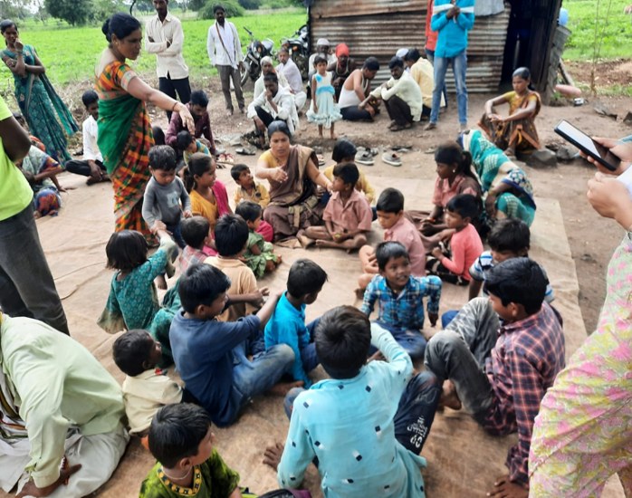

Acknowledgement

Working in partnership towards a common goal generates new learning and solutions. We cherish collaboration as our core value because the collaborative process enables Navchetna and our partners to combine our complementary knowledge, skills, and resources, making it possible for us to accomplish much more than we can on our own. The development of a partnership is a continuous process which demands active input from both sides. An effective partnership provides a greater chance of continuity, consistency, and sustainability for development. We are deeply indebted to the contributions and continued support rendered by our institutional partners, collaborators, resource institutions, philanthropists and well-wishers in the progress and achievements of the Navchetna SarvanginVikas Kendra.

Partner in Progress

- CII Foundation
- Start-up India
- Aajeevika Bureau
- Goonj
- Ketto
- NABARD
- NABFINS Ltd
- Smile Foundation
- Dasara

